LSA: Mental Health Resources
5 Ways to Wellbeing tool: https://www.nhs.uk/mental-health/self-help/guides-tools-and-activities/five-steps-to-mental-wellbeing/
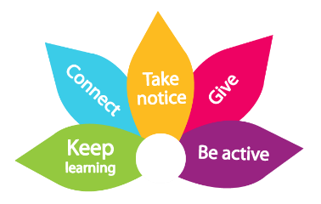
Mental Health Awareness Week 2021: https://www.mentalhealth.org.uk/campaigns/mental-health-awareness-week
Mental Health First Aid Training to improve mental health in the work-place: https://mhfaengland.org/
Mental Health First Aid Stress Container: https://mhfaengland.org/mhfa-centre/resources/address-your-stress/stress-container-resource-download.pdf
MIND, mental health at work resources: https://www.mind.org.uk/workplace/mental-health-at-work/. National MIND can also provide contact details for local MIND associations who will provide a range of services: https://www.mind.org.uk/
Mental Health Foundation - Managing Mental Health in the work place: https://www.mentalhealth.org.uk/publications/managing-mental-health-workplace
Mindfulness: Be Mindful Online. Online Mindfulness course supported by the Mental Health Foundation : https://www.bemindfulonline.com/
NICE (National Institute for Health & Care Excellence). Guidance for employers on promoting mental wellbeing at work: https://www.nice.org.uk/guidance/ph22
Public Health England & the NHS - Workplace Wellbeing Charter: https://www.wellbeingcharter.org.uk/
Time to Change – campaign closed in March 2021 but the website has lots of useful information and tools: https://www.time-to-change.org.uk/

